1. Technology

<https://blog.opporty.com/bls-threshold-signatures-implemented-to-opporty-plasma-cash-protocol-fead2736a08d>

We are continuing the development of our Plasma Cash protocol. Currently we are one of only two companies using this innovative technology. One more company has dabbled in it, but they have only one smart contract and it looks pretty simple.

<https://github.com/search?q=plasma+cash>

After completing our work on signatures, we will finalize the implementation of PoS.

During this process, there will be a scaling speed upgrade to 500,000 tx per second in the decentralized mode.

Our previous updates:

<https://blog.opporty.com/first-backend-version-of-plasma-solution-released-84faea72995f>

<https://blog.opporty.com/first-version-of-opporty-plasma-cash-solution-released-55c5dd9b2e25>

Kindly note that we have reached almost all the milestones described in our whitepaper. Some of them were released 1-2 months ahead of schedule.

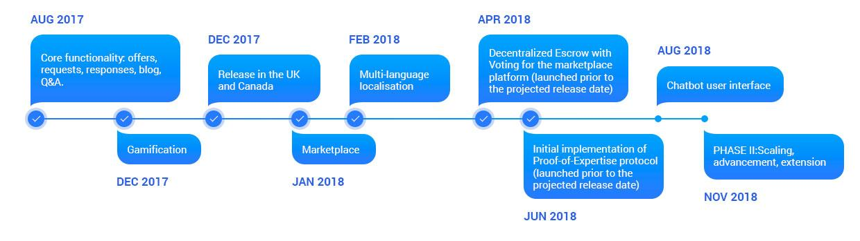

1. Team

*Current members:*

**Ms. Jing Zeng** - Former managing director of BNP Paribas China; General Manager of BNP Paribas Securities Services China; Director of the Asian Program of BNP Paribas Securities Services (Paris); Executive Director of Asian Development of the German Stock Exchange; Insead MBA.

**Charles Wong** - Special Assistant to Deputy Director at China Investment Forum OBOR(One Belt One Road) Development Center; Executive Committee, director of oversea department. Shanghai, Pudong; Hi-Tech Entrepreneur Federation; Executive VP Association of China International Country Economy Exchange.

**Raajiv Sami** - Raajiv is an entrepreneur with a solid background in wealth management and a comprehensive understanding of finance and technology. Some of the global brands Raajiv has represented include: St. James’s Place, MLC (part of the NAB group); AXA; AMP; Bankwest (part of the CBA Group); and ACAP (part of the Navitas group).

*Upcoming:*

**Mr. Sean C. Xia**

Professor of Law, Director of International Business and Law Research Center, Shanghai University of Political Science and Law; Senior Consultant, Dacheng Law Offices;

Arbitrator, Shanghai Arbitration Commission; Vice-President and Executive Council Member, China International Economic Cooperation Society (Ministry of Commerce); Committee Member of the China Democratic National Construction Association.

**Karl Frederick Rauscher**

Karl recently served as Ambassador-At-Large and Chief Architect of Cyberspace Policy at the 400,000+ member Institute of Electrical and Electronics Engineers (IEEE), where he encouraged technologists to engage in critical policy issues created by the digital revolution. While serving as CTO and Distinguished Fellow of the EastWest Institute, he led the first China-US and Russia-US bilateral talks on cybersecurity. In this regard, The New York Times editorial board recommended his guidance for US President Obama and Chinese President Xi prior to their meeting in 2013.

Previously, Karl was appointed Vice Chairman of US President George W. Bush's National Security Telecommunications Advisory Committee (NSTAC), Industry Executive Committee. He was elected by industry peers as Vice Chairman of the US Network Reliability Steering Committee (NRSC), was appointed to chair subcommittees of the US Federal Communications Commission (FCC) Network Reliability and Interoperability Council (NRIC), and served on the National Academy of Engineering / National Research Council Critical Infrastructure Roundtable. He is also founder and President of the nonprofit Wireless Emergency Response Team (WERT), which led advanced search and rescue efforts for survivors of the 9-11 terrorist attacks and Hurricane Katrina.

1. Business Development

The project is receiving significant interest in accordance with new government directives for the implementation of distributed ledger technologies among Chinese enterprises. Considering that we are one of the first two companies to develop Plasma Cash, and are also a member of Ethereum Enterprise Alliance, we fully meet the criteria.

For example, we are meeting this week with Mr. Si Jianguo to discuss the details of our showcase for the Small and Midsize Enterprise Association in China.

To explore similar opportunities here, we are meeting this Tuesday with Mr. Xie Yi. Deputy Director of Investment Development Center of Shanghai Changfeng Ecological Business District.

We are establishing strategic relations in the Chinese market with top companies in the legal niche, including HIWAYS, Shanghai Veritas, Shanghai Zhongwo Law Firm, and others.

We have also received a proposal from HIWAYS to organize a JV here in China. We will review potential partnership opportunities with them and several other companies.

One purpose of creating JV here in China is to establish a common and comfortable framework of collaboration in the local market.

1. Exposure

The project is gaining organic interest from conference organizers here in China. We are being invited, without sponsorship, to a wide number of events like <http://b-tasic.cn/en> , <https://www.gbls.io/>, X-Talks, July 7 compenttion by GBLS, Digital Asset Investment Forum, and others.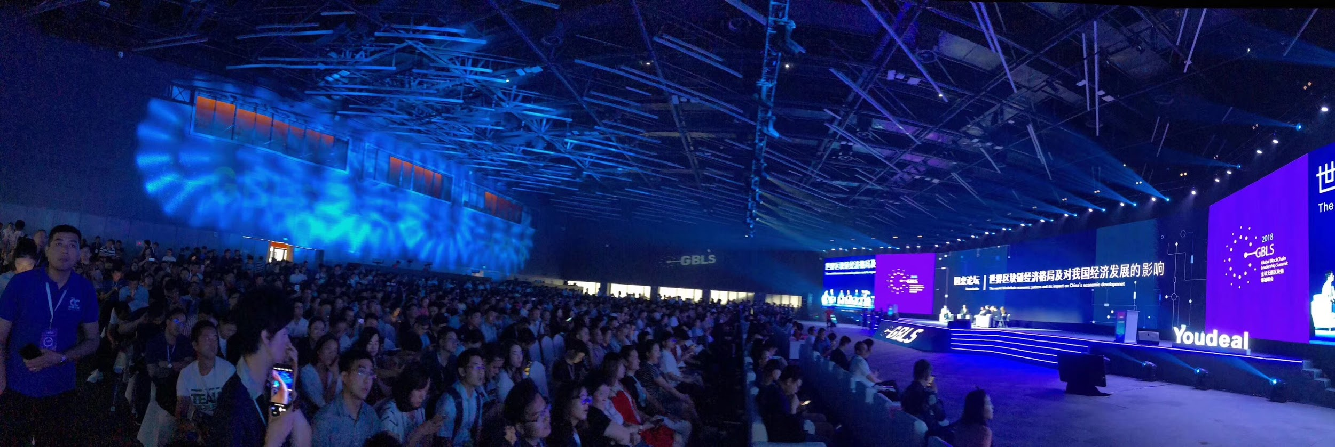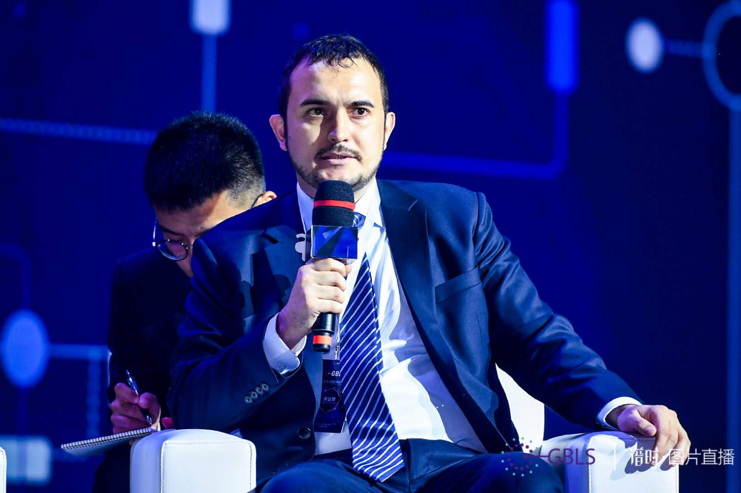

(Photos were taken during the panel discussion on GBLS on June 6).

5. Fundraising to date.

Total investments in the Opporty project exceed 1.2 M USD

Notable investor:

<https://threedcap.com/>



ThreeD Capital Inc. is a publicly-traded Canadian based venture capital firm trading on the Canadian Securities Exchange under the symbol “IDK”. ThreeD Capital Inc. was founded in 1987 and is based in Toronto, Canada. The firm seeks to invest in technology, with an emphasis on artificial intelligence and a focus on disruptive data science technologies, machine learning, and neuro networks; and blockchain sectors with a focus on blockchain assets.